

LAB-4

By-Arun Lal



Sec-E

BSCS(II)

CMS-ID=023-24-0120

Exercise of Lab: 4

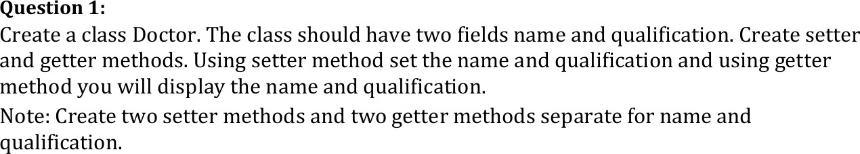

# CODE

class Doctor {

private String name,qualification;

public void setName(String name){this.name=name;}

public void setQualification(String qualification){this.qualification=qualification;} public String getName(){return name;}

public String getQualification(){return qualification;}

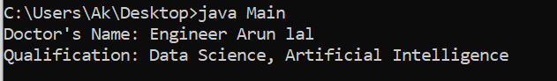}

public class Main {

public static void main(String[] args){ Doctor doc=new Doctor(); doc.setName("Dr. John Smith"); doc.setQualification("MBBS,MD"); S

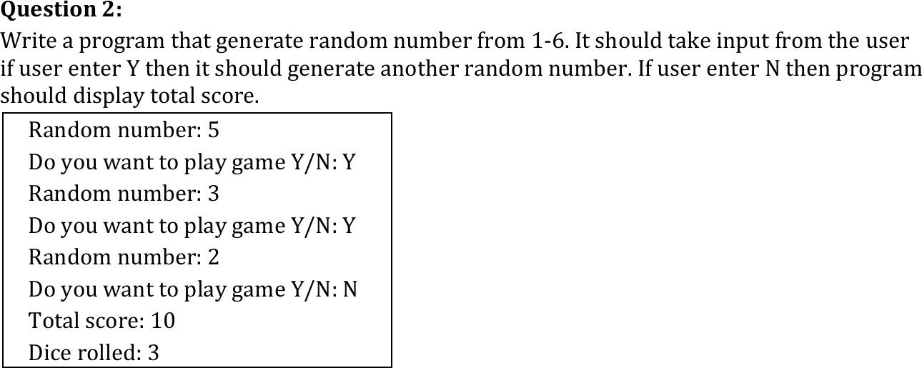

# CODE

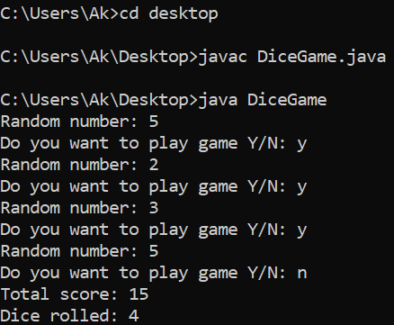import java.util.Random; import java.util.Scanner; public class DiceGame {

public static void main(String[] args) { Random rand = new Random();

Scanner scanner = new Scanner(System.in); int totalScore = 0;

int diceRolled = 0; char choice;

do {

int randomNumber = rand.nextInt(6) + 1; totalScore += randomNumber; diceRolled++;

System.out.println("Random number: " + randomNumber); System.out.print("Do you want to play game Y/N: "); choice = scanner.next().charAt(0);

} while (choice == 'Y' || choice == 'y'); System.out.println("Total score: " + totalScore); System.out.println("Dice rolled: " + diceRolled);

}

}

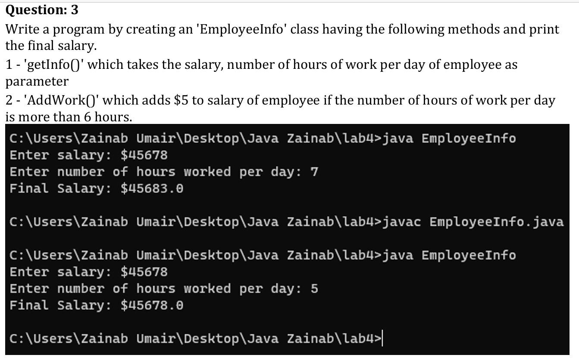

# CODE

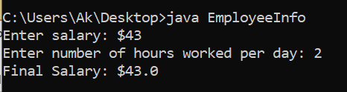import java.util.Scanner; class EmployeeInfo { double salary; int hours;

void getInfo(double sal, int hrs) { salary = sal;

hours = hrs;

}

void addWork() {

if (hours > 6) { salary += 5;

}

}

void printSalary() {

System.out.println("Final Salary: $" + salary);

}

public static void main(String[] args) { Scanner sc = new Scanner(System.in);

EmployeeInfo emp = new EmployeeInfo(); System.out.print("Enter salary: $"); double sal = sc.nextDouble();

System.out.print("Enter number of hours worked per day: ");

int hrs = sc.nextInt(); emp.getInfo(sal, hrs);

emp.addWork(); emp.printSalary(); sc.close();

}

}



# CODE

import java.util.Scanner;

import java.time.Year; class AgeCalculator {

public static void main(String[] args) { Scanner sc = new Scanner(System.in);

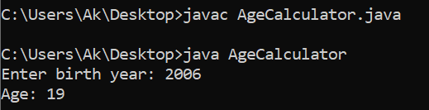System.out.print("Enter birth year: "); int birthYear = sc.nextInt();

int currentYear = Year.now().getValue();

int age = currentYear - birthYear;

System.out.println("Age: " + age); sc.close(); } }

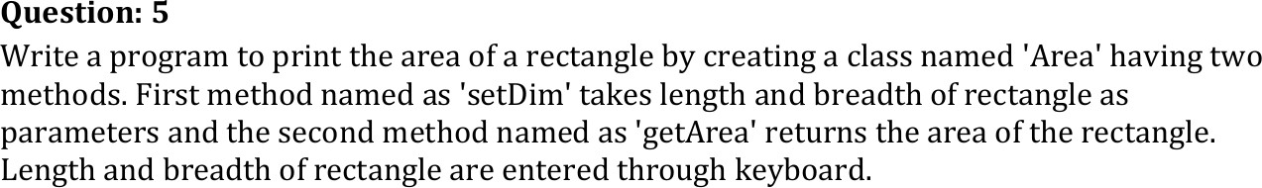

# CODE

import java.util.Scanner; class Area {

double length,breadth;

void setDim(double len,double brd){length=len;breadth=brd;} double getArea(){return length*breadth;}

public static void main(String[] args){

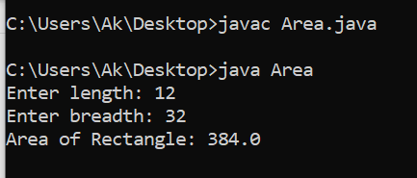Scanner sc=new Scanner(System.in); Area rect=new Area(); System.out.print("Enter length: "); double len=sc.nextDouble(); System.out.print("Enter breadth: "); double brd=sc.nextDouble(); rect.setDim(len,brd);

System.out.println("Area of Rectangle: "+rect.getArea()); sc.close();

}

}

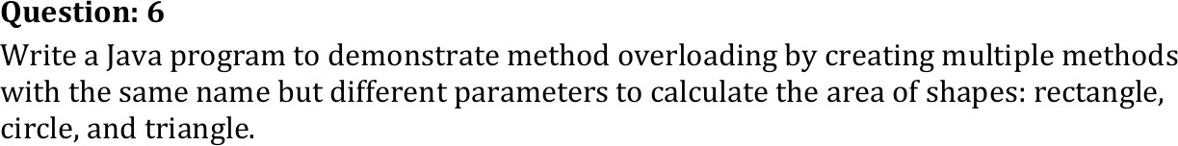

# CODE

import java.util.Scanner; class AreaCalculator {

double area(double length,double breadth){return length*breadth;} double area(double radius){return Math.PI*radius*radius;}

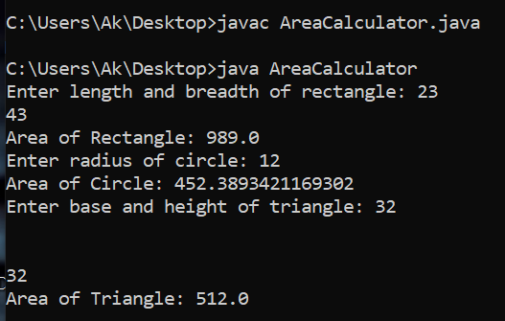double area(double base,double height,boolean isTriangle){return 0.5*base*height;} public static void main(String[] args){

Scanner sc=new Scanner(System.in); AreaCalculator obj=new AreaCalculator();

System.out.print("Enter length and breadth of rectangle: ");

double length=sc.nextDouble(),breadth=sc.nextDouble();

System.out.println("Area of Rectangle: "+obj.area(length,breadth));

System.out.print("Enter radius of circle: "); double radius=sc.nextDouble();

System.out.println("Area of Circle: "+obj.area(radius)); System.out.print("Enter base and height of triangle: "); double base=sc.nextDouble(),height=sc.nextDouble();

System.out.println("Area of Triangle: "+obj.area(base,height,true)); sc.close();

}

}

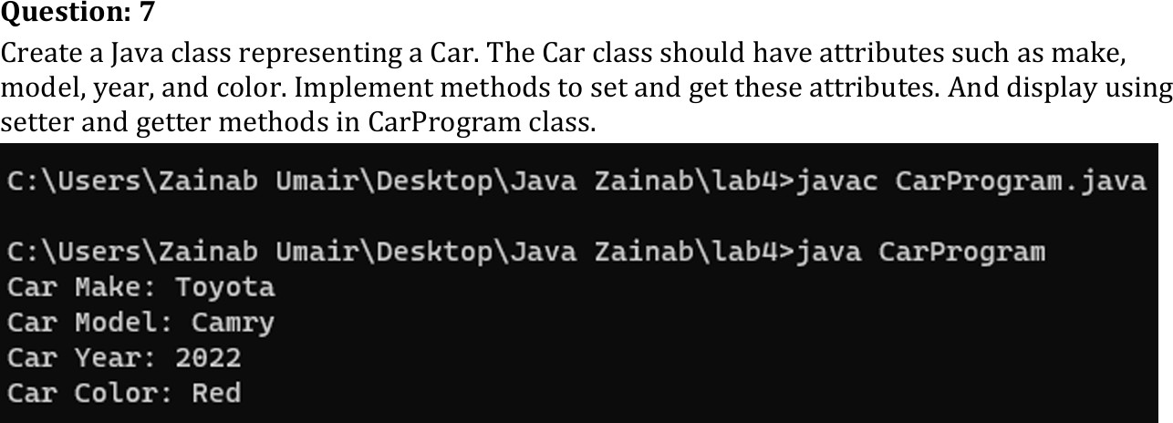

# CODE

class Car {

private String make,model,color; private int year;

public void setMake(String make){this.make=make;} public void setModel(String model){this.model=model;} public void setYear(int year){this.year=year;}

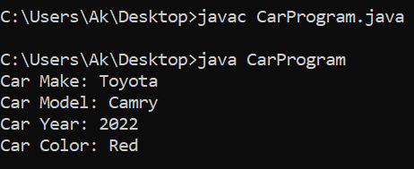public void setColor(String color){this.color=color;} public String getMake(){return make;}

public String getModel(){return model;} public int getYear(){return year;}

public String getColor(){return color;}

}

public class CarProgram {

public static void main(String[] args){ Car car=new Car(); car.setMake("Toyota"); car.setModel("Camry");

car.setYear(2022); car.setColor("Red");

System.out.println("Car Make: "+car.getMake()); System.out.println("Car Model: "+car.getModel()); System.out.println("Car Year: "+car.getYear()); System.out.println("Car Color: "+car.getColor());

}

}

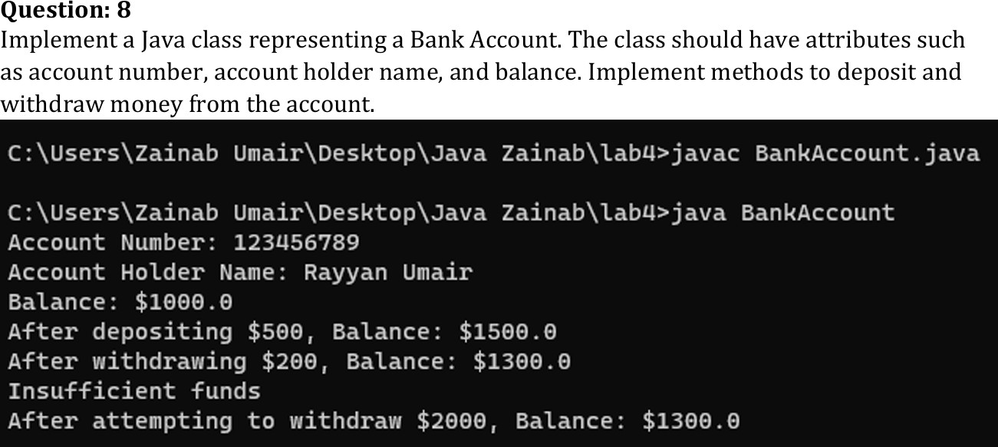

# CODE

class BankAccount {

private String accountNumber,accountHolderName; private double balance;

public BankAccount(String accountNumber,String accountHolderName,double balance){ this.accountNumber=accountNumber;

this.accountHolderName=accountHolderName; this.balance=balance; }

public void deposit(double amount){balance+=amount;}

public void withdraw(double amount){if(amount>balance)System.out.println("Insufficient funds");else balance-=amount;}

public double getBalance(){return balance;}

public String getAccountNumber(){return accountNumber;}

public String getAccountHolderName(){return accountHolderName;}

}

public class Main {

public static void main(String[] args){

BankAccount account=new BankAccount("123456789","Rayyan Umair",1000.0); System.out.println("Account Number: "+account.getAccountNumber()); System.out.println("Account Holder Name: "+account.getAccountHolderName()); System.out.println("Balance: $"+account.getBalance());

account.deposit(500);

System.out.println("After depositing $500, Balance: $"+account.getBalance()); account.withdraw(200);

System.out.println("After withdrawing $200, Balance: $"+account.getBalance()); account.withdraw(2000);

System.out.println("After attempting to withdraw $2000, Balance: $"+account.getBalance());

}

}

